Mechanism of the controlled release profiles of bisoprolol and its ion-pair from pressure sensitive adhesive in their transdermal drug delivery processes
Liang Fang*, Hanqing Zhao
Department of Pharmaceutical Sciences, School of Pharmacy, Shenyang Pharmaceutical University, 103 Wenhua Road, Shenyang, Liaoning 110016, China
* E-mail address: fangliang2003@yahoo.com

1. Introduction
Transdermal drug delivery system (TDDS), a successful controlled release technology which provides stable systemic drug concentration, has attracted increasing attention over the last 40 years. Among the methods usually used in TDDS, ion-pair strategy, as a simple but effective approach plays an important role in bidirectional regulation of drug skin permeation profile. However, investigations into the underlying mechanisms involved in the controlled release process of ion-pairs are still limited.

2. Purpose
In this lecture, we shall present our recent studies on the molecular mechanism of ion-pair controlling the transdermal delivery processes of bisoprolol (BSP), especially focusing on the roles of doubly ionic hydrogen bond formed between ion-pair and acrylic pressure sensitive adhesive containing carboxyl group (carboxylic PSA) on the controlled release process of BSP ion-pair.

3. Methods
BSP and BSP-lauric acid ion-pair (BSP-C₁₂) were used as model drugs due to their identical skin permeability coefficient (k_{p} = 1.9 $×$ ${10}^{-3}$ cm/h) based on our previous study [6]. Carboxylic PSA was designed and synthesized in order to improve drug loading and thus produce sustained release effect [4]. Effect of ion-pair on controlling BSP release from carboxylic PSA was investigated by in vitro drug release study and in vitro skin permeation study, then verified by pharmacokinetic study. Molecular mobility of PSA, along with the strength of drug-PSA interaction was evaluated by thermal analysis and dielectric spectroscopy (DES) [5, 13]. Molecular details of drug-PSA interaction were identified by Fourier transform infrared spectroscopy (FTIR), X-ray photoelectron spectroscopy (XPS) and Raman spectroscopy. Roles of drug-PSA interaction in the controlled release process were clarified by molecular modeling.

4. Results
4.1 Effect of ion-pair on controlling BSP release from carboxylic PSA
According to Fig. 1 – 3 and Table 1, both in vitro and in vivo skin permeation study testified that the skin absorption rate of BSP was successfully controlled, which was achieved by sustaining BSP release from carboxylic PSA by ion-pair.
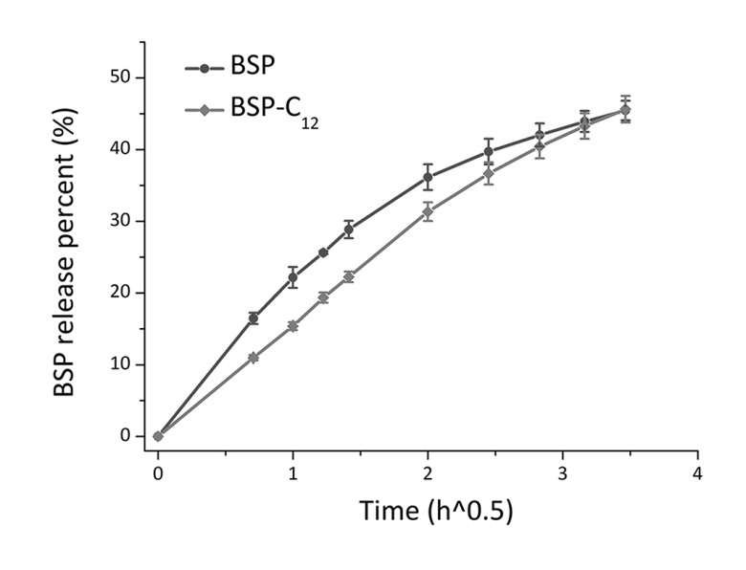
Fig. 1. Release profiles of BSP and BSP-C₁₂ transdermal patches (n = 4).
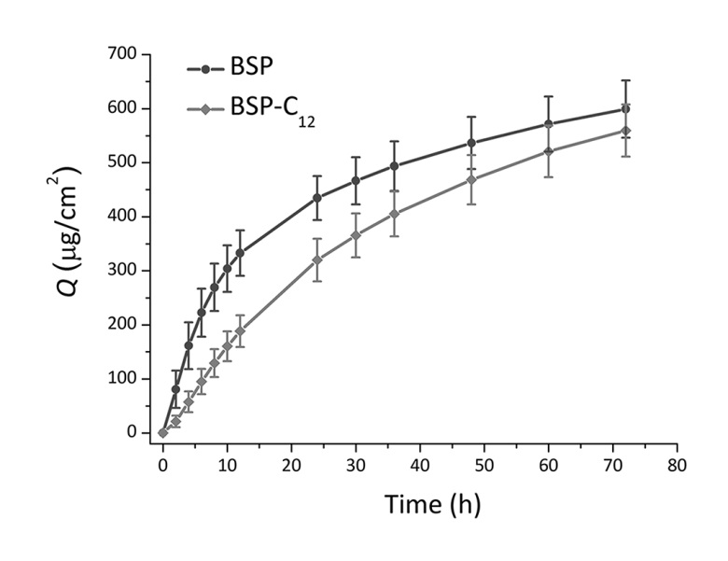
Fig. 2. In vitro skin permeation profiles of BSP and BSP-C₁₂ transdermal patches (n = 4).
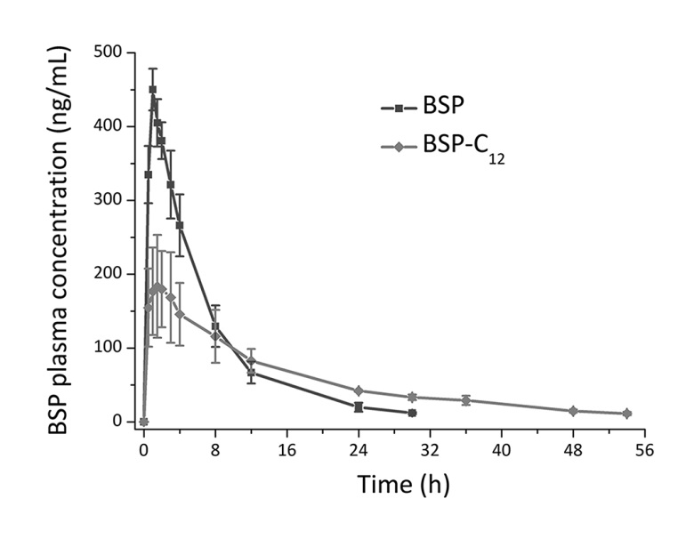
Fig. 3. Plasma BSP concentration-time curve after administration of BSP and BSP-C₁₂ transdermal patches (n = 6).

Table 1 Pharmacokinetic parameters of transdermal and i.v. administrations (n = 6).
Formulas | t_{max}  (h) | C_{max}  (ng/mL) | AUC  (h*ng/mL) | MRT  (h) | F  (%)
BSP patch | 1.0 ± 0.0 | 450 ± 28 | 3265 ± 468 | 7.9 ± 0.9 | 57.2
BSP-C₁₂ patch | 2.0 ± 0.6 | 193 ± 63 | 3289 ± 454 | 19.9 ± 3.4 | 57.6
BSP (i.v.) | - | - | 543 ± 51 | 0.9 ± 0.2 | -

4.2 Mechanism study on ion-pair controlling the transdermal delivery processes of BSP
4.2.1 PSA molecular mobility
4.2.1.1 Thermal analysis
Glass transition temperature (T_{g}) of PSA and polymer-drug interaction parameter (A) calculated by WLF equation [10] were listed in Table 2. T_{g} value of BSP and BSP-C₁₂ loaded PSA decreased about 3 °C and 7 °C separately compared with blank PSA. Besides, A value of BSP-C₁₂ loaded PSA was lower than that of BSP loaded PSA. These results not only demonstrated that molecular mobility of BSP-C₁₂ loaded PSA was higher than BSP loaded PSA, but it also indicated that stronger molecular interaction existed between BSP-C₁₂ and PSA compared to that between BSP and PSA.

Table 2 T_{g} and A value of blank PSA and drug loaded PSAs.
Sample | T_{g} (°C) | A
blank PSA | -35.8 | -
PSA + BSP | -38.9 | 8.7
PSA + BSP-C₁₂ | -42.8 | 8.3

4.2.1.2 DES
Loss tangent spectra of PSAs were shown in Fig. 4. Relaxation times (τ) of PSAs were obtained from Fig. 4, which further proved that molecular mobility of the BSP-C₁₂ loaded PSA was higher than the BSP loaded PSA, and stronger molecular interaction existed between BSP-C₁₂ and PSA compared to that between BSP and PSA, which were consistent with the results of thermal analysis [12].
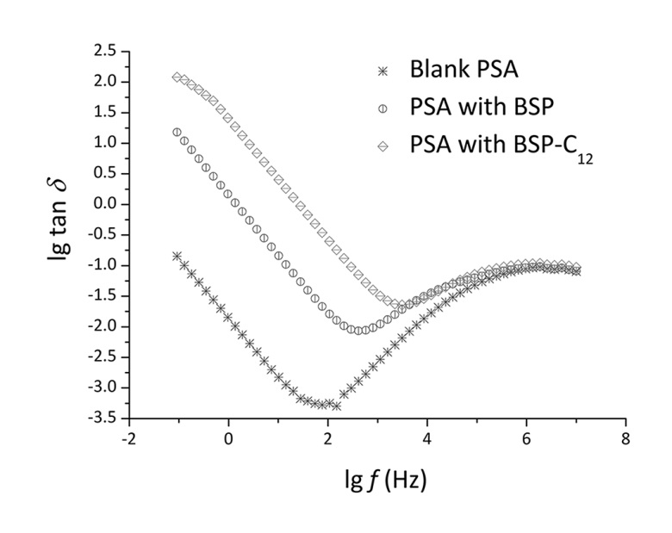
Fig. 4. Loss tangent as a function of frequency of blank PSA and drug loaded PSAs.

4.2.2 Molecular details of drug-PSA interaction
4.2.2.1 FTIR spectra
Wavenumber shifts in FTIR spectra shown in Fig. 5 – 6 indicated that apart from the ionic bond between BSP or BSP-C₁₂ and PSA, there was also H-bond formed between BSP or BSP-C₁₂ and PSA, with the deprotonated PSA-COO– being the H-bond interaction site of PSA [3, 8].
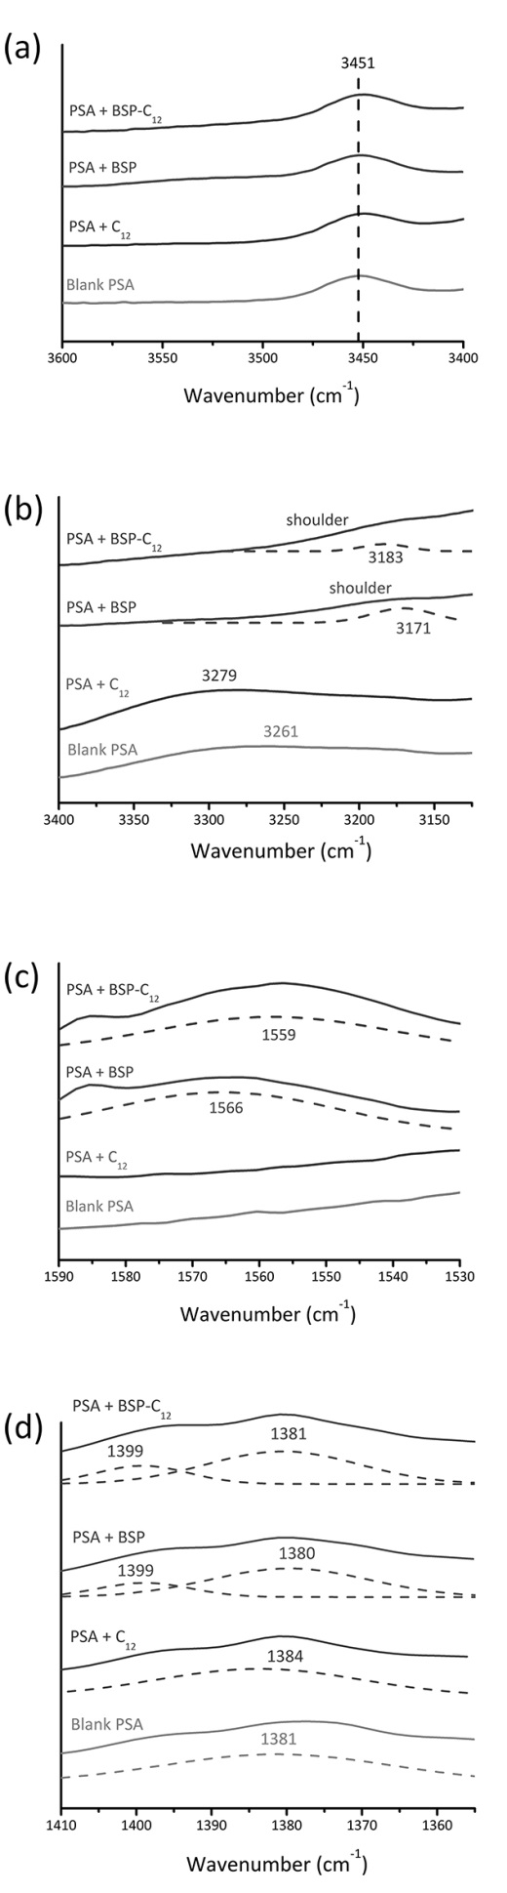
Fig. 5. FTIR spectra of blank PSA and PSA loading BSP, C₁₂ and BSP-C₁₂, with dashed lines referring to deconvoluted peaks.
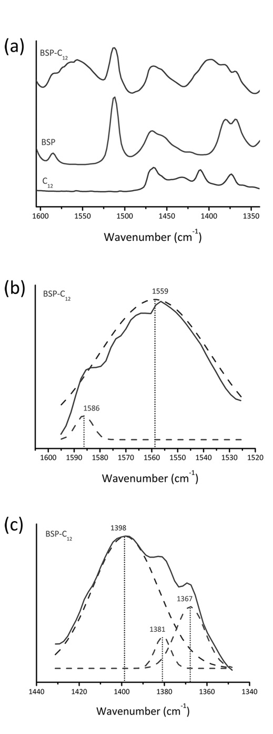
Fig. 6. FTIR spectra of BSP, C₁₂ and BSP-C₁₂, with dashed lines referring to deconvoluted peaks.

4.2.2.2 XPS
XPS spectra shown in Fig. 7 indicated that two states of BSP existed in the BSP loaded PSA: the protonated BSPH⁺ and the free BSP, while the BSP molecules were completely protonated to BSPH⁺ in the BSP-C₁₂ loaded PSA [15].
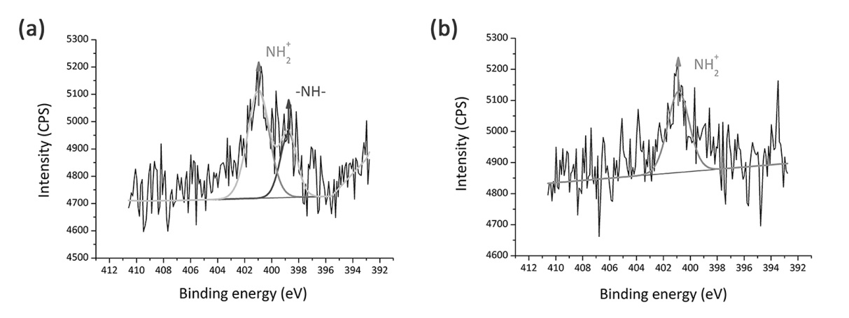
Fig. 7. XPS N 1 s peaks obtained from (a) BSP loaded PSA (b) BSP-C₁₂ loaded PSA.

4.2.2.3 Raman spectra
Wavenumber shifts in Raman spectra shown in Fig. 8 indicated that in addition to ionic interaction, there was H-bond formed between BSP or BSP-C₁₂ and PSA, with the secondary amine group (-NH-) being the H-bond donor of BSP, and the protonated secondary amine group (−NH+ 2−) being the H-bond donor of BSP-C₁₂ [1, 14].
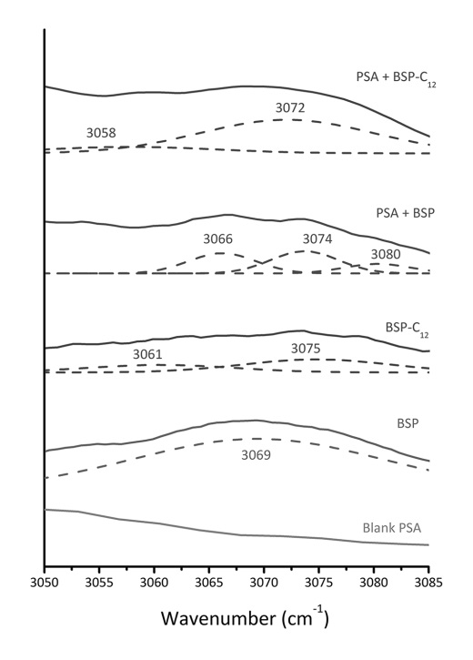
Fig. 8. Raman spectra of blank PSA, BSP, BSP-C₁₂, PSA loading BSP and BSP-C₁₂, with dashed lines referring to deconvoluted peaks.

4.2.2.4 Molecular modeling
Fig. 9 illustrated that BSP formed stable ionic interaction with PSA or C₁₂, and the ionic interaction between BSP and PSA was more stable than that between BSP and C₁₂. What’s more, according to Fig. 10, it was found that stronger H-bond interaction was formed between BSP-C₁₂ ion-pair (−NH+ 2−) and PSA-COO– than that between BSP (-NH-) and PSA-COO– [2].
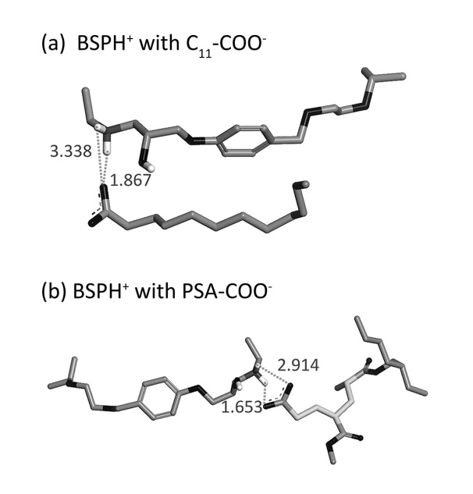
Fig. 9. Optimal conformations of (a) BSPH⁺ with C11-COO– (b) BSPH⁺ with PSA-COO⁻.
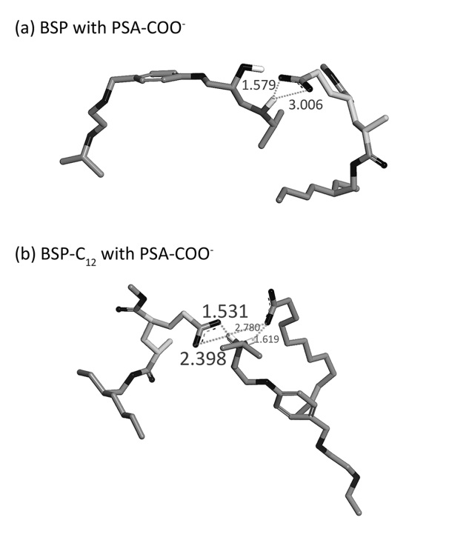
Fig. 10. Optimal conformations of (a) BSP with PSA-COO⁻ (b) BSP-C₁₂ with PSA-COO⁻.

4.2.2.5 DES
Apart from τ, DES also provided dielectric constants of PSAs. Dielectric constant of BSP-C₁₂ loaded PSA (ε′ = 14.1 – 50.4 in 32 °C) was much larger than that of BSP loaded PSA (ε′ = 6.8 – 10.4 in 32 °C) in all tested frequencies, indicating that the polarity of PSA loading BSP-C₁₂ was higher that loading BSP [7].

5. Conclusion
In the present study, it was found that BSP-C₁₂ ion-pair controlled the transdermal delivery rate of BSP without significantly influencing its delivery amount from transdermal patches. Molecular interaction between model drug and PSA played a dominant role in BSP’s release process instead of PSA mobility. As illustrated in Fig. 11, from thermodynamic aspect, whether BSP or BSP-C₁₂ molecules were loaded to patches, the binding state of them both provided BSPH⁺ and formed identical ionic bonds with PSA-COO⁻, leading to their equivalent release amounts; from kinetic aspect, the doubly ionic H-bond formed between the undissociated BSP-C₁₂ and PSA-COO⁻ was stronger than the ionic H-bond formed between the free state of BSP and PSA-COO⁻, controlling the release rate of BSP [9, 11].
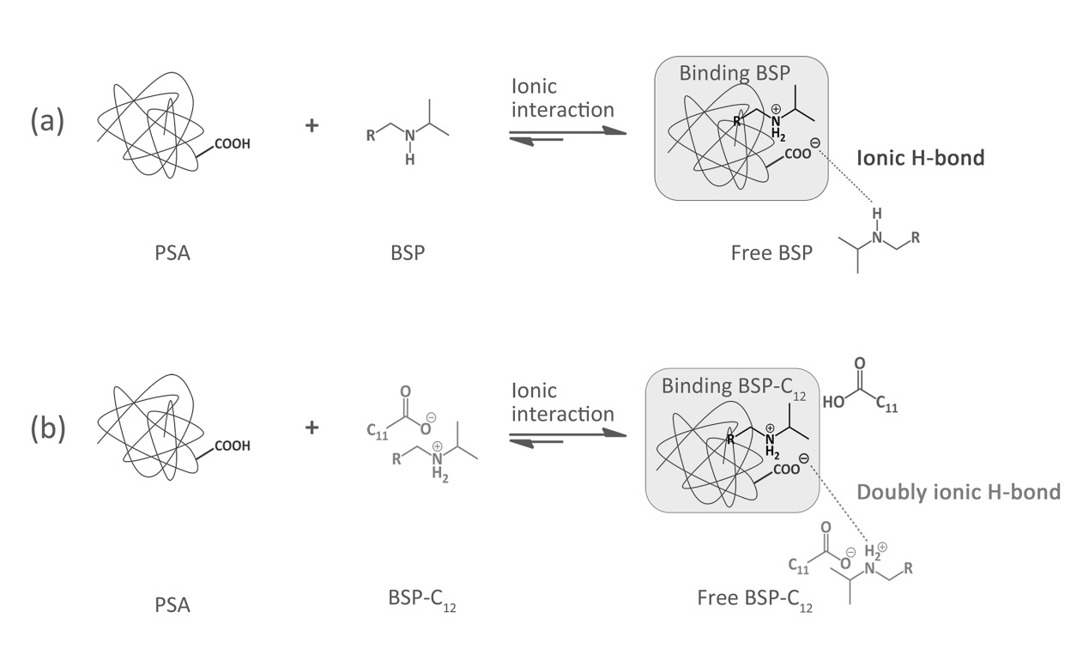
Fig. 11. Molecular interactions involved in the controlled release processes of (a) BSP and (b) BSP-C₁₂.

References
[1] A.G. P., A.-D. Osama, K. Febe, H. Peter, H. Zhai, J.D. S., Physicochemical characterization and drug-release properties of celecoxib hot-melt extruded glass solutions, J. Pharm. Pharmacol. 2010; 62: 1580–1590.
[2] C. Liu, P. Quan, S. Li, Y. Zhao, L. Fang, A systemic evaluation of drug in acrylic pressure sensitive adhesive patch in vitro and in vivo: the roles of intermolecular interaction and adhesive mobility variation in drug controlled release, J. Control. Release. 2017; 252: 83–94.
[3] D.A. Quinteros, R.H. Manzo, D.A. Allemandi, Interaction between Eudragit® E100 and anionic drugs: Addition of anionic polyelectrolytes and their influence on drug release performance, J. Pharm. Sci. 2011; 100: 4664–4673.
[4] D. Yang, X. Wan, P. Quan, C. Liu, L. Fang, The role of carboxyl group of pressure sensitive adhesive in controlled release of propranolol in transdermal patch: Quantitative determination of ionic interaction and molecular mechanism characterization, Eur. J. Pharm. Sci. 2018; 115: 330–338.
[5] H. Kaden, F. Koniger, M. Stromme, G.A. Niklasson, K. Emmerich, Low-frequency dielectric properties of three bentonites at different adsorbed water states, J. Colloid Interface Sci. 2013; 411: 16–26.
[6] H. Zhao, C. Liu, P. Quan, X. Wan, M. Shen, L. Fang, Mechanism study on ion-pair complexes controlling skin permeability: effect of ion-pair dissociation in the viable epidermis on transdermal permeation of bisoprolol, Int. J. Pharm. 2017; 532: 29–36.
[7] K. Kothari, V. Ragoonanan, R. Suryanarayanan, The role of drug-polymer hydrogen bonding interactions on the molecular mobility and physical stability of nifedipine solid dispersions, Mol. Pharm. 2015; 12: 162–170.
[8] M.H. Fung, M. Devault, K.T. Kuwata, R. Suryanarayanan, Drug-excipient interactions: effect on molecular mobility and physical stability of ketoconazole organic acid coamorphous systems, Mol. Pharm. 2018; 15: 1052–1061.
[9] M. Meot-Ner Mautner, Update 1 of: strong ionic hydrogen bonds, Chem. Rev. 2015; 112: Pr22–103.
[10] M. Yasunori, K. Takemasa, S. Kenji, Diffusion of drugs in acrylic-type pressure sensitive adhesive matrix. II. Influence of interaction, J. Control. Release. 1992; 18: 113–121.
[11] P.A. Hunt, C.R. Ashworth, R.P. Matthews, Hydrogen bonding in ionic liquids, Chem. Soc. Rev. 2015; 44: 1257–1288.
[12] P. Mistry, S. Mohapatra, T. Gopinath, F.G. Vogt, R. Suryanarayanan, Role of the strength of drug-polymer interactions on the molecular mobility and crystallization inhibition in ketoconazole solid dispersions, Mol. Pharm. 2015; 12: 3339–3350.
[13] S.P. Bhardwaj, R. Suryanarayanan, Molecular mobility as an effective predictor of the physical stability of amorphous trehalose, Mol. Pharm. 2012; 9: 3209–3217.
[14] T.A. de Toledo, R.C. da Costa, R.R.F. Bento, P.S. Pizani, Hydrostatic pressure and temperature effect on the Raman spectra of the molecular crystal 2-amine-1,3,4-thiadiazole, J. Mol. Struct. 2018; 1156: 127–135.
[15] Y. Song, D. Zemlyanov, X. Chen, H. Nie, Z. Su, K. Fang, X. Yang, D. Smith, S. Byrn, J.W. Lubach, Acid-base interactions of polystyrene sulfonic acid in amorphous solid dispersions using a combined UV/FTIR/XPS/ssNMR study, Mol. Pharm. 2016; 13: 483–492.

Key words: ion-pair, pressure sensitive adhesive, doubly ionic hydrogen bond, controlled release, transdermal

