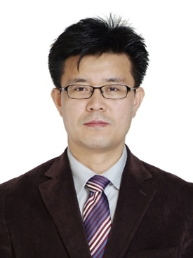
Youngjoo Byun, Ph.D.

Professor
College of Pharmacy, Korea University
2511 Sejong-ro, Sejong 30019, Korea

Tel: +82-44-860-1619
Email: yjbyun1@korea.ac.kr

Education
1990-1994 B.S. Seoul National University, South Korea
1994-1996 M.S. Seoul National University
2001-2006 Ph.D. Ohio State University, USA

Positions and Employment
1996-2001 Senior Scientist, AmorePacific R&D Center
2006-2007 Postdoctoral Fellow, School of Medicine, Johns Hopkins University
2007-2009 Research Associate, School of Medicine, Johns Hopkins University
2009-2011 Instructor, School of Medicine, Johns Hopkins University
2011-2013 Assistant Professor, College of Pharmacy, Korea University
2013-2017 Associate Professor, College of Pharmacy, Korea University
2017- Professor, College of Pharmacy, Korea University

Awards
Excellent Research Scientist, 2000, AmorePacific R&D Center
Young Scholar Award, 2016, Korean Society of Organic Synthesis

Representative Publications (since 2015)
- H. S. Kim; S. H. Lee; Y. Byun*; H. D. Park*, 6-gingerol reduces pseudomonas aeruginosa biofilm formation and virulence via quorum sensing inhibition, Scientific Reports, 2015, 5, 8656
- M Subedi, I Minn, J Chen, YH Kim, K Ok, YW Jung, MG Pomper, Y Byun*, Design, synthesis and biological evaluation of PSMA/hepsin-targeted heterobivalent ligands, European Journal of Medicinal Chemistry, 2016, 118, 208-218
- H Choi. SY Ham, E Cha, HS Kim, JK Bang, SH Son, HD Park*, Y Byun*, Structure-activity relationships of 6- and 8-gingerol analogs as anti-biofilm agents, Journal of Medicinal Chemistry, 2017, 60(23), 9821-9837
- H Kim, K Kim, S-H Son, JY Choi, K-H Lee, B-T Kim, Y Byun*, YS Choe*, ¹⁸F-Labeled BODIPY dye: A potential prosthetic group for brain hybrid PET/Optical imaging agents, ACS Chemical Neuroscience, 2019, 10(3), 1445-1451
- BB Park, JW Choi, D Park, D Choi, J Paek, HJ Kim, S-Y Son, A Mushtaq, H Shin, SH Kim, Y Zhou, T Lim, JY Park, J-Y Baek, K Kim, H Kwon, S-H Son, KY Chung, H-J Jeong, H-M Kim, YW Jung, K Lee, KY Lee*, Y Byun*, YH Jeon*, Structure-activity relationships of baicalein and its analogs as novel TSLP inhibitors, Scientific Reports, 2019, 9, 8762
- SH Son, Y Byun*, N Sakairi*, Selection of neighboring group participation intermediates of fully acylated donors around the glycosylation sites in oligosaccharide acceptors, Organic Letters, 2019, 21(23), 9368-9371

