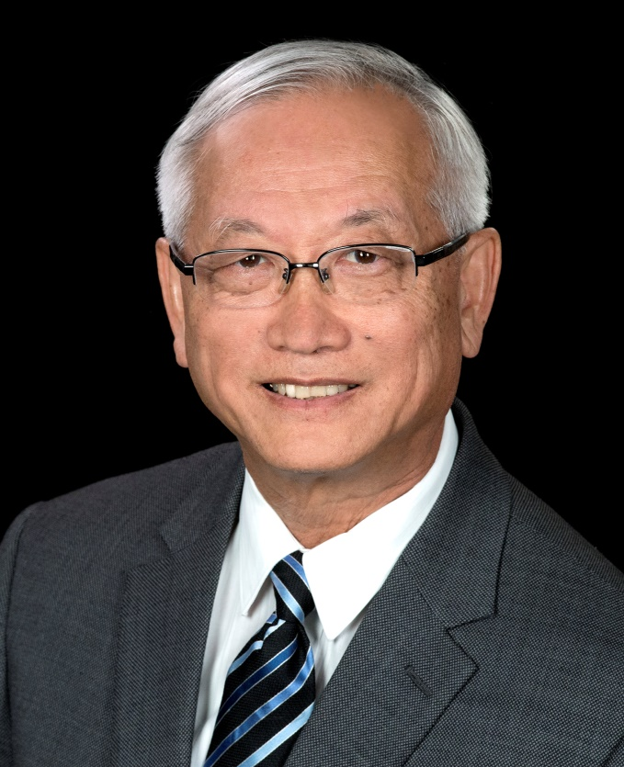
Benjamin K. Tsang, PhD

Director, Reproductive Biology Unit,
Professor, Departments of Obstetrics & Gynaecology and Cellular & Molecular

Medicine, Interdisciplinary School of Health Sciences, University of Ottawa

Senior Scientist, Chronic Disease Program, Ottawa Hospital Research Institute

Email: btsang@ohri.ca
Website: www.ohri.ca/profiles/tsang.asp

Telephone: 613-737-8899 x72926 (Office), x73886 (Laboratory), x72807 (Res. Admin. Assistant)
Biographical Sketch
Dr. Ben Tsang completed his undergraduate training at Bemidji State University (chemistry), received MSc (Biochemistry) from the University of Iowa, and Ph.D. (Pharmacology) from the University of Ottawa. In 1980, Dr. Tsang joined the University of Ottawa as the Director, Reproductive Biology Unit and initiated a research-intensive academic program in the Department of Obstetrics and Gynaecology. He served as Associate Chair (Research) of the Department, and developed a multi-disciplinary reproductive health research program in Ottawa. As the Director of Research of the Ottawa Civic Hospital, he played a central role in research development at the Loeb Research Institute, now one of the top health research institutions in Canada and recently named the Ottawa Hospital Research Institute.
Professor Tsang is an internationally recognized ovarian biologist, who has successfully developed a translational research program in women’s health. His team of basic scientists and clinical investigators address important health issues, including female infertility, ovarian cancer and pregnancy complications. Dr. Tsang’s research program covers the broad area of cell fate regulation in women’s reproductive health. He and his team are examining the cell signaling pathways involved in the regulation of ovarian cell survival and apoptosis and have defined the basic mechanisms governing normal ovarian follicular growth and offered important insights into the pathophysiology of polycystic ovarian syndrome. In addition, his research on the molecular and cellular basis of chemoresistance in ovarian cancer has provided key information for the development of new therapy for chemoresistant ovarian cancer, a most lethal cancer in women. The success of Professor Tsang’s research program is also reflected by his ability to secure continuous funding from MRC/CIHR during the past 37 years, as well as support from other peer-review funding agencies, government departments, private foundations and industries. To date, he has contributed over 225 original publications and 20 reviews/book chapters and issued 4 US patents.
Professor Tsang has received many honors and awards, including the Award of Excellence in Reproductive Medicine from the Canadian Fertility and Andrology Society, The OCRI Research Award from the Ottawa Centre for Research and Innovations, Angel Award for cancer research excellence from the Ottawa Regional Cancer Foundation, “Outstanding Alumnus” of Bemidji State University (Minnesota), the J David Grimes Research Career Achievement Award at the Ottawa Hospital Research Institute, University of Ottawa Faculty of Medicine Award of Excellence (Research) and Recognition Award (Medical Education).
Professor Tsang was elected as President of the Canadian Fertility and Andrology Society and as a member of the Board of Directors of the Society for the Study of Reproduction. He holds honorary professorship at the Chinese Academy of Sciences, Jinan University, Nanjing Medical University and Taipei Medical University. He was appointed the World Class University Professor of Biomodulation, Department of Agricultural Biotechnology at the Seoul National University. He serves on the Advisory Committee of the Cancer Research Institute, Seoul National University. He co-chairs the Canada-Japan Bilateral Program on Women’s Health Research and the Sino-Canada Bilateral Program on Reproductive Health. He is an Editor-in-Chief of the Journal of Ovarian Research, and served on the Editorial Board of Endocrinology, Biology of Reproduction, Reproduction and Adaptive Medicine.

