Michael J. Krische
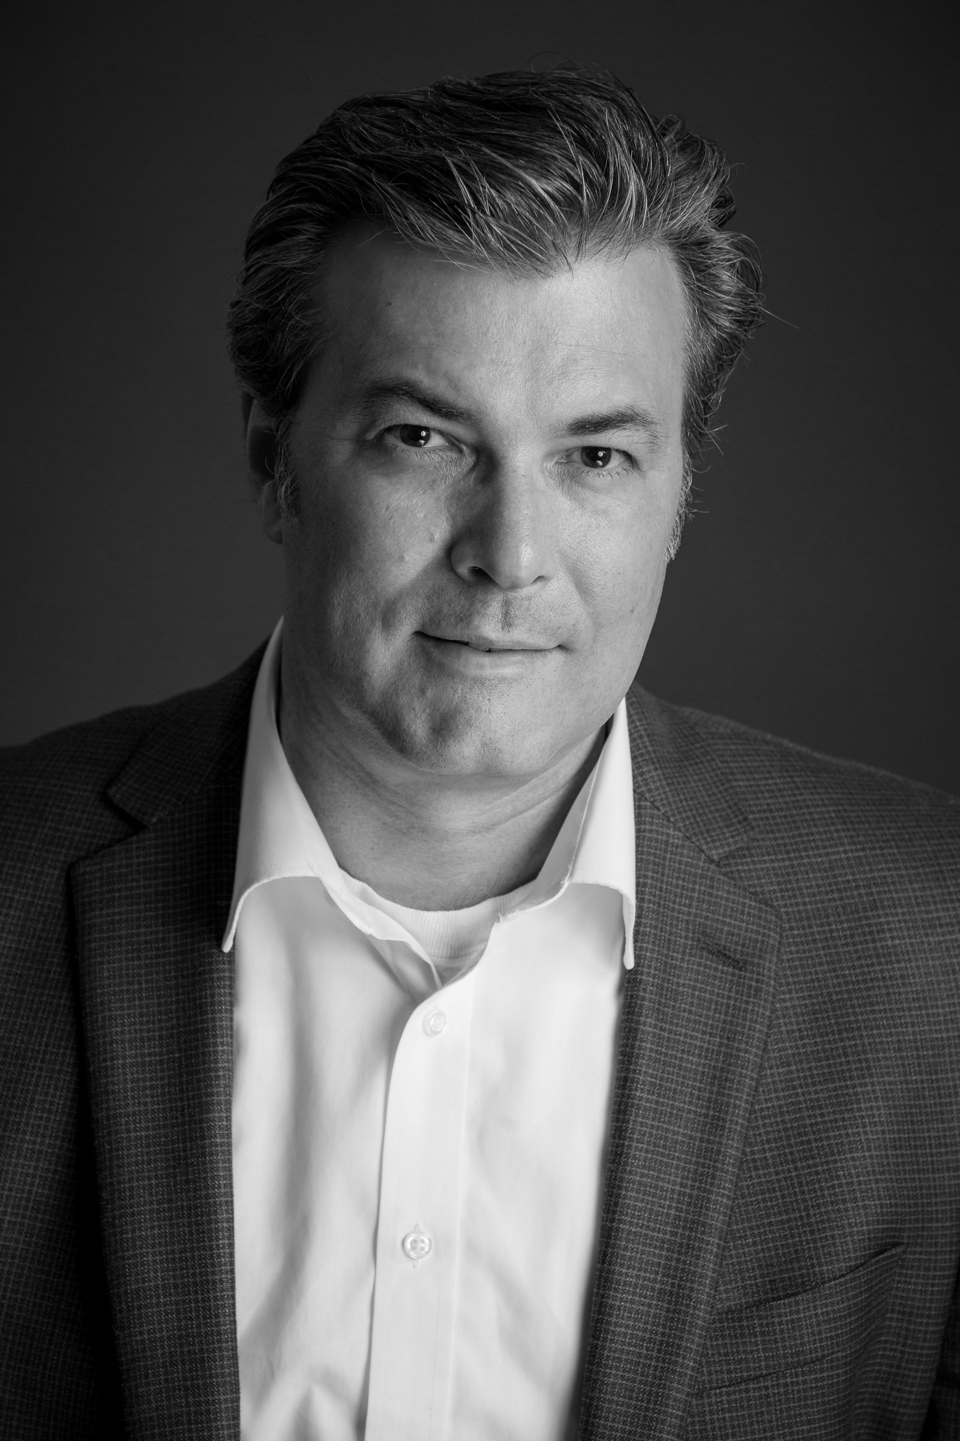to]

Professor of Chemistry
University of Texas at Austin
Department of Chemistry
105 E 24th St. (A5300)
Austin, TX 78712-0165
Tel: (512) 232-5892
E-mail:mkrische@mail.utexas.edu

Education
B.S. Chemistry, Univ. of California at Berkeley
Advisor: Professor Henry Rapoport (8/86-8/89)

Ph.D. Chemistry, Stanford University (9/90-12/96)
Advisor: Professor Barry M. Trost

NIH Post-Doc., Université Louis Pasteur (1/97-8/99)
Advisor: Professor Jean-Marie Lehn

Academic Careers
Robert A. Welch Chair in Science
University of Texas at Austin (9/07-Present)

Professor of Chemistry (Direct Promotion from Asst. Prof.)
University of Texas at Austin (9/04-Present)

Assistant Professor of Chemistry
University of Texas at Austin (9/99-8/03)

Awards
NSF-CAREER Award (2000), Cottrell Scholar Award (2002), Eli Lilly Granteeship for Untenured Faculty (2002), Frasch Award in Chemistry (2002), Dreyfus Teacher-Scholar Award (2003), Sloan Fellowship (2003), Johnson & Johnson Focused Giving Award (2005), Solvias Ligand Prize (2006), Presidential Green Chemistry Award (2007), ACS Corey Award (2007), Dowpharma Prize (2007), Novartis Lectureship (2008), Tetrahedron Young Investigator Award (2009), Humboldt Senior Research Award (2009-2011), Mukaiyama Award (2010), Glaxo-Smith-Kline Scholar Award (2011), ACS Cope Scholar Award (2012), JSPS Fellow (2013), Eun Lee Lectureship, Korea (2015), Royal Society of Chemistry, Pedlar Award (2015), AAAS Fellow (2017), Ta-Shue Chou Lectureship Award, Academia Sinica, Taiwan (2019), ACS Award for Creative Work in Synthetic Organic Chemistry (2020)

Representative Publications
- “Metal Catalyzed Reductive Coupling of Olefin-Derived Nucleophiles: Reinventing Carbonyl Addition,” Nguyen, K. D.; Park, B. Y.; Luong, T.; Sato, H.; Garza, V. J.; Krische, M. J. Science 2016, 354, 300.
- “Feedstock Reagents in Metal-Catalyzed Carbonyl Reductive Coupling:Minimizing Preactivation for Efficiency in Target-Oriented Synthesis,” Doerksen, R. S.; Meyer, C. C.; Krische, M. J. Angew. Chem. Int. Ed. 2019, 58, 14055.
Hydrogen-Mediated C-C Bond Formation
Professor Michael J. Krische, PhD, FRSC, FAAAS*
University of Texas at Austin, Department of Chemistry (A5300) AUSTIN, TX 78712-0165

Stereo- and site-selective methods for the byproduct-free modification of unprotected organic compounds that occur through the addition or redistribution of hydrogen are natural endpoints in the advancement of methods for efficient, green chemical synthesis.¹ Progress toward this goal requires a departure from reactants that embody non-native structural elements, such as premetalated reagents, directing/protecting groups and chiral auxiliaries. Our laboratory has developed a broad, new family of reductive C-C bond formations that merge the characteristics of catalytic hydrogenation and carbonyl addition.² Hydrogenation or transfer hydrogenation of π-unsaturated reactants in the presence of C=X (X = O, NR) bonds delivers products of carbonyl or imine addition. In related hydrogen auto-transfer reactions, alcohols served dually as reductants and carbonyl proelectrophiles, enabling direct conversion of lower alcohols to higher alcohols.³ Such hydrogen-mediated C-C bond formations contribute to a departure from the use of stoichiometric organometallic reagents, and the issues of safety, selectivity, and waste posed by their use.

Acknowledgement
The Robert A. Welch Foundation (F-0038), the NIH-NIGMS (RO1-GM069445, R01-GM093905) and the NSF (CHE-1565688) are acknowledged for financial support.
References
1. “Feedstock Reagents in Metal-Catalyzed Carbonyl Reductive Coupling:Minimizing Preactivation for Efficiency in Target-Oriented Synthesis,” Doerksen, R. S.; Meyer, C. C.; Krische, M. J. Angew. Chem. Int. Ed. 2019, 58, 14055.
2. “Unlocking Hydrogenation for C-C Bond Formation: A Brief Overview of Enantioselective Methods,” Hassan, A.; Krische, M. J. Org. Proc. Res. Devel. 2011, 15, 1236.
3. “Catalytic Enantioselective Carbonyl Allylation and Propargylation via Alcohol Mediated Hydrogen Transfer: Merging the Chemistry of Grignard and Sabatier,” Kim, S. W.; Zhang, W.; Krische, M. J. Acc. Chem. Res. 2017, 50, 2371.

